M. G. Science Institute, Ahmedabad
Autonomous | Affiliated to Gujarat University, Ahmadabad
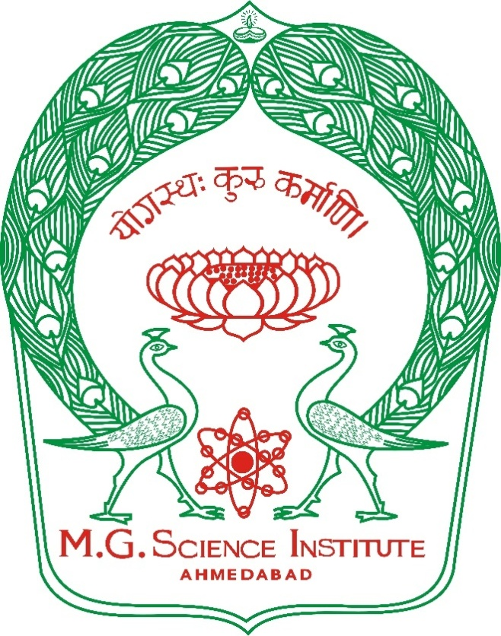

(Managed by The Ahmadabad Education Society)
Department of English

Bachelor of Science (Hons.)
B.Sc. (Hons.)
Semester-VI
English
(Foreign students)
(AEC-365)

(Effective from Academic Year 2025-26)
Ability Enhancement Course (AEC) – English

AEC – English (Semester-6)
Academic Year 2025–26
M.G. Science Institute (Autonomous)
For foreign students
Syllabus Document

Course Objectives:
To develop comprehension and analytical skills through simplified biographical essays.
To strengthen advanced grammar usage for academic and scientific contexts.
To improve written communication with focus on CV/resume writing and professional expression.
To encourage self-expression through short and long answer questions.
To prepare students for future academic and professional challenges.
Course Content:
Part A: Prose (Biographical Essays)
Steve Jobs – Innovation and Technology
Mahatma Gandhi – Truth and Non-Violence
Taylor Swift – Art, Business, and Economics
Albert Einstein – Science and Curiosity
Dr. A.P.J. Abdul Kalam – Science and Leadership
Part B: Advanced English Grammar for Science Students
Subject–Verb Agreement in Scientific Writing
Passive Voice in Scientific Reports
Tense Usage in Research Descriptions
Vocabulary for Science and Technology
Practice Exercises
Part C: Communication Skills
CV and Resume Writing
Cover Letter Basics
Presentation Skills (oral & written)
Email Etiquette for Academic & Research Communication
Paper Style (25 Marks Total)
External Exam (20 Marks):
1. Shorter questions & Short Notes (Prose) – 10 Marks
2. MCQs (Prose + Grammar) – 5 Marks
3. Grammar Exercises – 5 Marks
Or
4. CV/Resume Writing – 5 Marks
Internal Assessment (5 Marks):
– Assignment / Presentation / Viva
Evaluation Method
Understanding of prose (essays & Q/A)
Application of grammar in scientific writing
Ability to prepare a professional CV
Communication clarity in written assignments
Course Outcomes:
After completing the course, students will be able to:
- Understand and respond to English prose
- Use textual and common English vocabulary with
- Apply grammar accurately in written communication
- Communicate clearly in academic and professional contexts

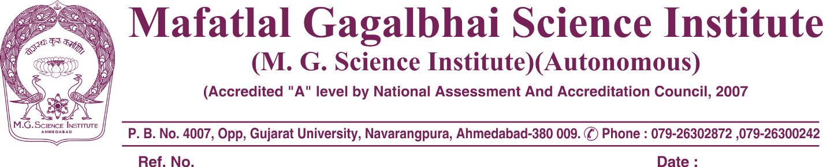

Minutes of the Meeting: Board of Studies in English

- A meeting of the Board of Studies (BOS) in English was convened on 30 January 2026, at 12.15 PM at M.G. Science Institute**, Navrangpura, Ahmedabad.
- The agenda included an in-depth discussion on various aspects of the syllabus for the Ability Enhancement Course (AEC) for English(For foreign students) and HINDI.
- Members of the BOS provided valuable suggestions regarding the syllabus. After thorough deliberation, the proposed syllabi were reviewed and unanimously approved by the Board.
SIGNATORIES:
Board of studies (English):

1. | Dr. R.K. PUJARA | HOD
2. | PROF. S.M. BHATAIYA | FACULTY
3 | DR. NUTAN KOTAK | VC- NOMINEE  GUJARAT UNI.
4 | DR. CHARUDATT GURJAR | S.P. UNIVERSITY  VIDYANAGAR
5. | DR. KISHANKUMAR JOSHI | CVM UNIVERSITY, ANAND
6. | DR. VAISHALI THAKKER | ALUMNI

